**Module 6: Multisensory Rooms**

**6B Projector**

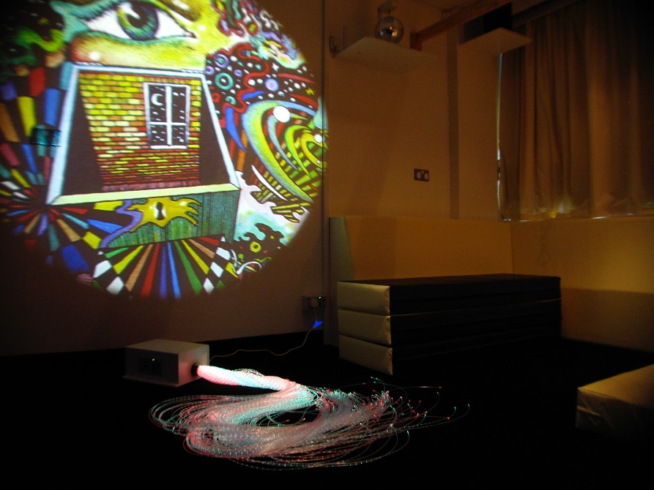

The wheel projector in sensory rooms is a very simple piece of equipment but very practical.

When working with learners who have autism, you could project onto the back of a large white umbrella to enclose the learner in a little controlled space. This will help them to regulate the visual information they are receiving. It will also create a focal point if you are using a wheel with imagery the learner likes.

For learners with a sensory loss projected light through a white sheet is a really great tool for visual stimulation. But the projector can also be a great scene setter for a sensory story.

1. Use the wheel projector for encouraging visual tracking skills.

2. The wheels rotate once every two minutes on most projectors so it can be great for prediction skills.

3. Learn how to make your own wheels and use them in a story or maths or literacy lesson.

4. Use coloured sweet wrappers or other transparent sheets to make a colour wheel.